- Relational model and algebra
A database is a collection of relations and each relation is an unordered set of tuples (or rows). Each relation has a set of attributes (or columns). Each attribute has a name and a domain and each tuple has a value for each attribute of the relation.
Key: superkey一组属性集 唯一确定表中一个touple。如果minimal 则叫做candidate key. 专门设计的candidate key是primary key 比如唯一属性ID. Foreign key引用另一个表的某个属性：CREATE TABLE Enrollments (
EnrollmentID INT PRIMARY KEY,
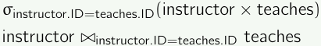
StudentID INT,
CourseID INT,
FOREIGN KEY (StudentID) REFERENCES Students(StudentID)
);
Selection σ_{dept_name=′′Physics′′}(instructor) get rows
Projection Π_{ID,name,salary/12}(instructor) redefine cols
Product R×S all possible combinations
Join R ▷◁_θ S = σ_θ(R×S)
Natural join: based on their common attributes
Union R∪S: concat Difference R−S
Renaming ρ_{S(A1,A2,...,An)}(R) rename table and attr.

Highest salary: Π_salary(instructor) – Π_instructor.salary
(instructor ▷◁_{instructpor.salary<d.salary} ρ_d(instructor))
SQL
create table department -- sql is insensitive to caps
(dept_name varchar(20),-- sql is insensitive to white spaces
building varchar(15) not null,
budget numeric(12,2),
primary key(dept_name));-- primary key constraint, cant be null
drop table department;
NULL means that the value is unknown or not applicable.
INSERT INTO R(A_1,..,A_n) VALUES (v_1,...,v_n);
DELETE FROM instructor WHERE name='Turing';
SELECT ID, name FROM instructor WHERE dptmt = 'Comp. Sci.';
SELECT * from instructor;
SELECT ID, name, salary/12 FROM instructor;
SELECT student.name, instructor.name
FROM student, advisor, instructor
WHERE student.ID = advisor.S_ID
AND advisor.i_ID = instructor.ID;
SQL adopts bag (i.e., multiset) semantics by default.– That is, duplicates are allowed in query results
SELECT DISTINCT dept_name from instructor;
SELECT DISTINCT name
FROM instructor, advisor AS S, advisor AS T
WHERE instructor.ID=S.i_ID AND
S.i_ID = T.i_ID AND S.s_ID <> T.s_ID;
SELECT ... FROM ... [WHERE ...]
ORDER BY ..., column[ASC|DESC], ...;
SELECT * FROM instructor ORDER BY salary DESC, name;
(in sql)eliminate duplicates by default:
SELECT ... FROM ... WHERE ...
UNION|INTERSECT|EXCEPT
SELECT ... FROM ... WHERE ...;

SELECT dept_name, AVG(salary)
FROM instructor
GROUP BY dept_name
HAVING COUNT(*) > 10;
NULL:
NULL op value/NULL = NULL (计算)
NULL θ value/NULL = UNKNOWN (Comparison)
Aggregation functions ignore NULL, except COUNT(*)
Evaluating aggregation functions (except COUNT) on an empty bag returns NULL
NULL cannot be used explicitly used an operand
• TRUE = 1, FALSE = 0, UNKNOWN = 0.5
• x AND y =min(x,y)
• x OR y=max(x,y)
• NOT x =1−x
R JOIN S ON join_condition
R NATURAL JOIN S
A left outer join between R and S, denoted as R ▷◁S includes
both
• rows in R ▷◁ S, and
• dangling R rows padded with NULL’s
ON vs. WHERE
-- NULL values are preserved
SELECT * FROM course LEFT OUTER JOIN prereq
ON course.course_id = prereq.course_id;-- NULL values are left out
SELECT * FROM course LEFT OUTER JOIN prereq ON TRUE
WHERE course.course_id = prereq.course_id;
Functional dependencies
Let X = {A1,...,An} and Y = {B1,...,Bm} be sets of attributes.
A functional dependency (FD) is of the form X →Y that requires the attributes of X functionally determining the attributes Y.
Given a relation R, a set X of attributes is a candidate key if
• Xfunctionally determines all other attributes of R, i.e., X is a superkey.
• No proper subset of X functionally determines all other attributes of R.
logically implies 描述的是两个FD的集合的逻辑关系
The closure of X under F, X_F^+, is the set of all attributes B such that F logically implies X → B
Let F = {A →B,A→C,CD→E,CD→K,B→E}. Then
• {A}F+= {A,B,C}, {C,D}F+= {C,D,E,K}.
• {A,D}F+= {A,B,C,D,E,K}
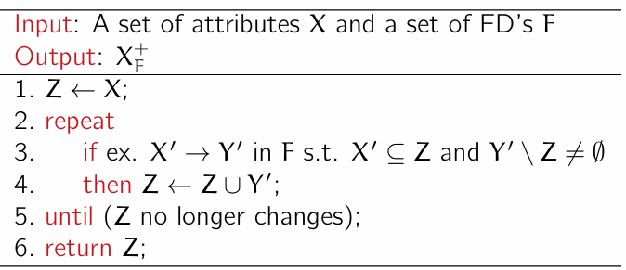
Computing attribute closure
The closure of F, denoted by F+, is the set of all FD’s logically implied by F.
Armstrong’s axioms
• Reflexivity: If Y ⊆ X, then X → Y.
• Augmentation: If X → Y, then XZ → YZ.
• Transitivity: If X → Y and Y → Z, then X → Z.
A canonical cover Fc of F is a minimal set of FD’s equivalent to F.
• No FD in Fc contains an extraneous attribute.
• Each LHS of a FD in Fc is unique.
An attribute of a FD X → Y in FD is extraneous if we can remove it without changing F+
• (F \ {X → Y}) ∪ {(X \ {A}) → Y}
• (F \ {X → Y})∪{X →(Y \{B})}
1. A∈X is extraneous in X → Y iff Y ⊆ (X\{A})+F.
2. B ∈Y is extraneous in X → Y iff B ∈ X+F′, where F′ = (F\{X → Y})∪{X → (Y\{B})}.
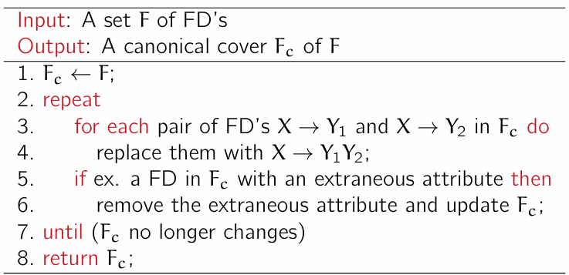
Computing canonical cover
Lossless join decomposition I =I(R1) ▷◁ ... ▷◁ I(Rn) (proof).
A decomposition of relation schema R: 要求属性覆盖R中全部
Lemma: join lossless if:
For every X → Y in F, there exists some Ri that contains all the attributes in XY;At least one schema in the decomposition contains a candidate key of R.
Boyce-Codd Normal Form
R is in BCNF w.r.t. a set F of FD of for all FD in F+,
• X→Y is trivial.
• X is a superkey of R, i.e., X → R is in F+.
If a relation is in BCNF, then no redundancy can be observed by means of FDs
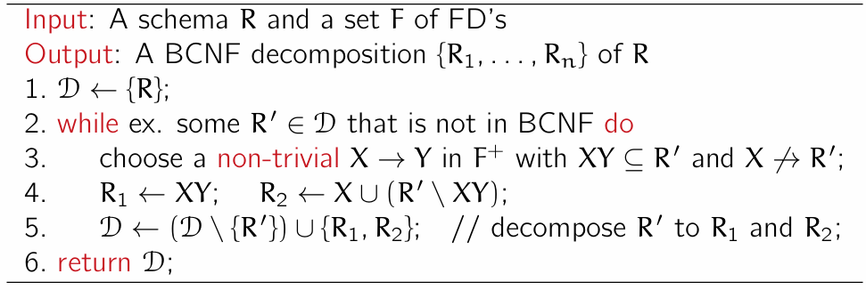
BCNFdecomposition algorithm
Let F be a set of FD’s on a schema R, and let R1,…, Rn be a decomposition of R. The restriction of F to Ri is the set Fi of all FD’s in F+ that include only attributes of Ri.
F+ =(∪ i=1 n Fi)+, dependency preserving
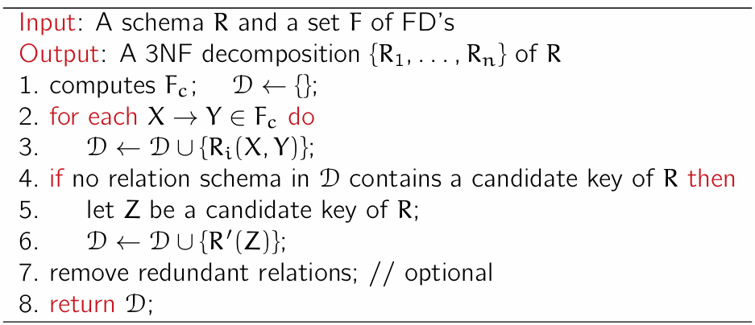
3NF Every attribute in Y \ X is contained in a candidate key of R.
A database file is a collection of pages, each holding a collection of tuples.
• Heap files: Tuples are placed arbitrarily across pages.
• Sorted files: Pages and tuples are are stored in a specific order.
• Index files: B+ trees, hashing tables and others.
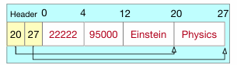
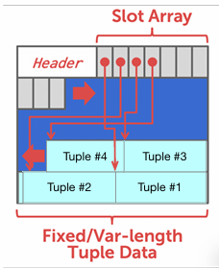
A database page is a fixed-size block of data. Each page is given a unique page id as its identifier.
Buffer pool: 1frame1page, metadata include dirty bit, ref count
Pagereplacement policies
LRU: Replace the least recently used unpinned frame.
Clock: ref bit-=1. Skip pinned. In the example in class, ref bit init 1 with pin.
Index file: {searchkey:pointer}, order/hash
dense/sparce:单index可以指向多个 而sparce是指per block等
Clustering index: search key order also defines the sequential order of data records/primary index.
B+树 log ⌈n/2⌉N
node contains at most n−1 search keys and n pointers. P1K1P2
• Pi points the sub-tree of search keys K with Ki−1 ⩽ K <Ki
• Pn, i.e., next-leaf pointer.
• Balance: all leaves are at the same level.
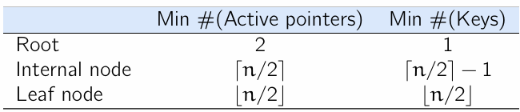
• Occupancy: all nodes (except root) are at least half-full.
Delete
1. Find the correct leaf L.
2. Remove the entry from L for the given key.
◦ If L is still half-full, the operation is done.
◦ If L becomes under-full, then
(a) First try to redistribute by borrowing one from siblings.
(b) If redistribution fails, then merge L and a sibling.
3. When merging two leaf nodes, remove from the parent the key associated
with the two leaf nodes to be merged.
4. When merging two non-leaf nodes, pull down the associated key instead.
5. When borrowing from internal nodes, rotate the borrowed key through the parent node.
6. Process the nodes recursively until all nodes are half-full.
External merge sorting
• Pass 0: read B pages of R each time, sort them, and write out a level-0 run.
• Pass i: merge B−1 level-i-1 runs each time, and write out a level-i run. 1 page for output
#(Passes) log B−1⌈P(R)/B⌉ + 1
#(Read Pages) P(R)∗(log B−1⌈P(R)/B⌉+1)
#(Write Pages) P(R)∗log B−1⌈P(R)/B⌉
Total cost 2P(R)∗log B−1⌈P(R)/B⌉ + P(R)
Blocked nested loop join
Total cost: P(R) +⌈P(R)/(B −2)⌉∗P(S)
Hash Join
• Partition both R into B −1 partitions, using a hash function h on the join attributes.
• Reserved the output buffer for each partition.
• Partition table S in the same way.
• Read each partition Ri and build table using hash function g.
• Read the corresponding partition Si of S in a per-page basis; then probe and join.
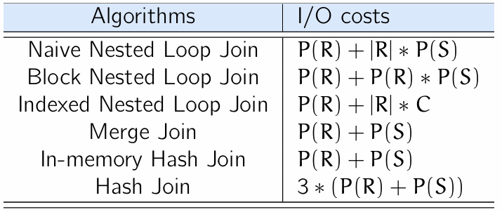
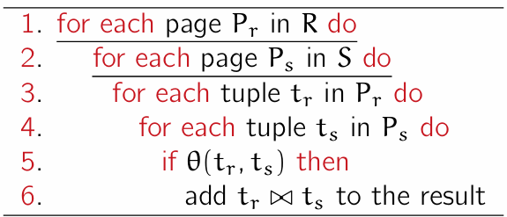
• R is the build relation and S is the probe relation.
C is the I/O cost of an index lookup
Basic equivalence rules
R ▷◁ S = S ▷◁ R. (ii) (R ▷◁ S) ▷◁ T = R ▷◁ (S ▷◁ T)
σθ(R×S) =R▷◁θ S
sigma条件直接and，proj条件覆盖忽略
Rules-based query optimization
Push selection/projection down as much as possible.
Join small relations first, and avoid cross products
Cost estimation
|σA=v∧B=u(R)| = |R|/NDV(A,R)∗NDV(B,R)
Selectivity factor for A= v is 1 − 1/NDV(A,R)
Or：1/NDV(A,R) + 1/NDV(B,R) −1/NDV(A,R)∗NDV(B,R)
σA<v(R)：v−min(A,R) / max(A−R)−min(A,R)
join：|R|∗|S|/max(NDV(B,R),NDV(B,S))[containment of value sets]
Optimal substructure property. Any subplan of an optimal join plan must also be optimal.
Dynamic programming: Opt_Cost(S) = minR∈S{Opt_cost(S\{R})+Join_cost(S\{R},R)}
A transaction (“TXN”) is a collection of database operations that servers as a single, indivisible logical unit of work.
Atomicity Consistency Isolation Durability
Serial: TXN无交叉serializable equivalent to serial schedule.
Conflict：access same data item, at least 1 operation is a write.
Conflict Equivalent: S, S′ are schedules of same set of TXNs.
Every pair of conflicting operations is ordered in the same way.
Precedence graph
node represents TXN. edge represents a conflicts between two TXNs.– (Ti,Tj) in E indicates a pair of conflicting operation Oi ∈ Ti and Oj ∈ Tj such that Oi appears before Oj in S.
Two-Phase Locking (2PL)
• Growing: (i) a TXN may obtain; (ii) may not release.
• Shrinking: (i) a TXN may release; (ii) may not obtain new locks.
Strict 2PL: “Release exclusive locks only after TXNs committed”.
Atimestamp-ordering (T/O) protocol
TXN T receives a unique timestamp TS(T)
◦ W−TS(A): the largest TS(T) of any txn T wrote A successfully.
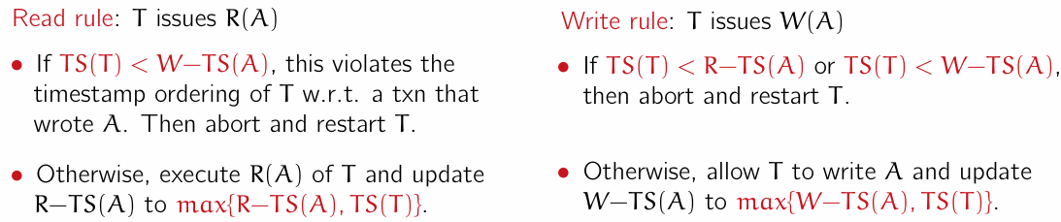
◦ R−TS(A): the large TS(T) of any txn T read A successfully
Log records
• ⟨Ti start⟩: Ti has started.
• ⟨Ti,X,Vold,Vnew⟩: Ti executes W(X) to update its values
• ⟨Ti commit⟩: Ti has committed.
• ⟨Ti abort⟩: Ti has aborted.
No-Force: A TXN can commit even if its updates have not been flushed to disk.
Good performance, need to check log to redo
Steal: A buffer pool page with uncommitted updates can be flushed to disk anytime. Need to check undo
WAL rule: Log records that correspond to the changes made to a DB object must have been written to disk before the DB object is allowed to be flushed to disk.
periodically takes a checkpoint where it flush all buffers to disk.
1. Stop accepting new TXNs.
2. Flush all log records currently residing the memory.
3. Flush all dirt pages to disk.
4. Write a log record ⟨checkpoint L⟩ to disk.– L is a list of TXN still active at the time of checkpoint.

